Stock calculation for options
OpenCart version 2.3.0.2 – Ocmod preffered
Purpose
Better stock control and calculation for product options when used for different packaging alternative.
How it works today
No matter what the option you purchase is the quantity in the product’s data tab will only subtract by one. This makes stock control impossible for us since we sell the same product in a variety of different packaging sizes.
What we need
1.
Make a specific product option subtract a pre-defined amount from the quantity in the data tab for the product sold. By giving all options (under Catalog > Options in admin) a value or worth, 0 or empty meaning default OC behavior, other numbers trigger a subtraction in the sold product’s data tab equal to the set value/worth. The subtract stock i products options should still behave as normal.

Example
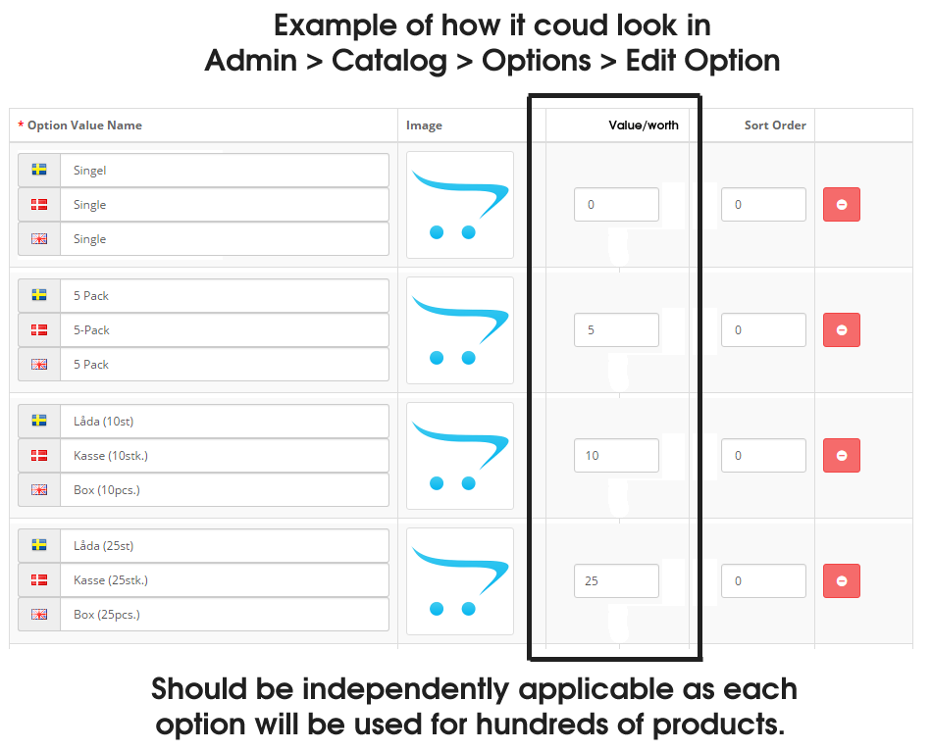
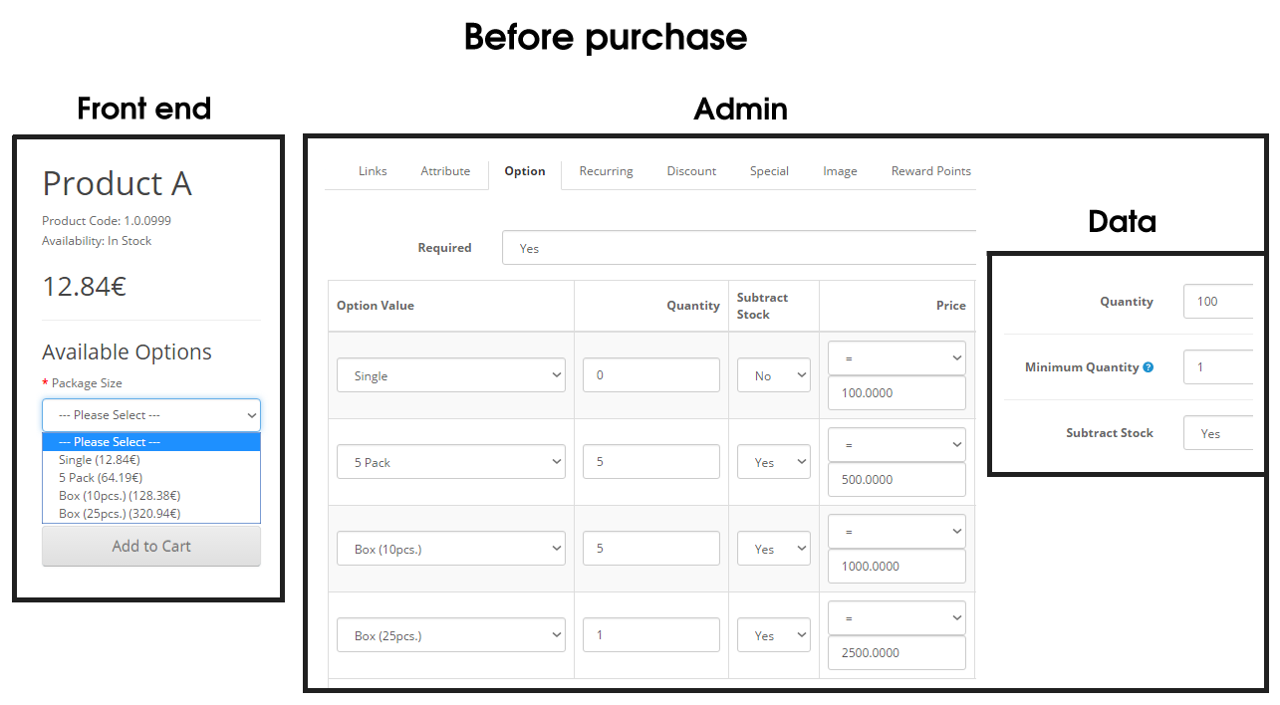
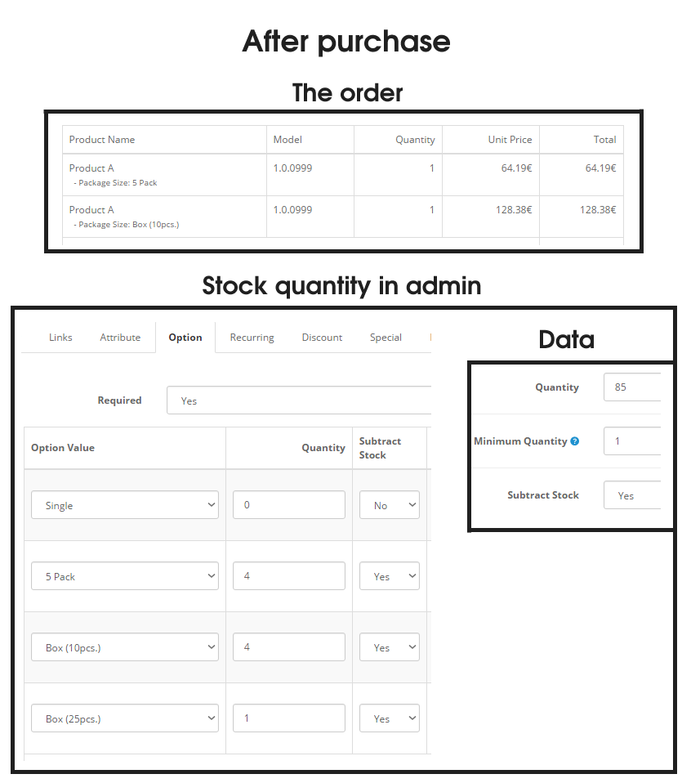

2.
When a product’s options are loaded, the quantity in the data tab should be checked and if that quantity is lower than the value/worth for any option, those options should be hidden (or grayed out/unable to choose) even though that option’s quantity might not be 0.

Example
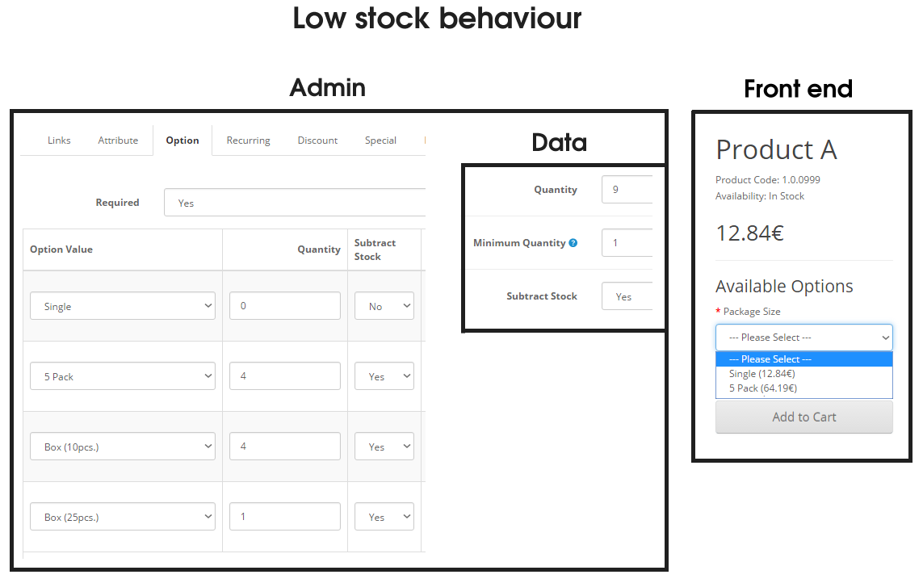

Everything should be independently applicable as each
option will be used for hundreds of products.

Kind regards
David Nilsson
Kind Group AB

